NBIA 5.0.2

Title of Publication

Local Installation Guide






Center for Biomedical Informatics and Information Technology
Table of Contents

Introduction 1
NBIA 5.0.2 Software and Technology Requirements 2
Java SDK Installation 3
Apache Ant Installation 3
Apache Ant Environment Variables 3
MySQL Installation and Configuration 6
Oracle Installation and Configuration 7
Downloading and Installing UPT 8
Installing NBIA 5.0.2 Application and Services 8
Downloading NBIA 5.0.2 files 9
Installing a New NBIA 5.0.2 10
GUI Installer Method of Installation 10
Installing NBIA One Component at a Time 22
Command-Line Method of Installation 23
About Properties 23
Command-line Installation Steps 25
Upgrading NBIA 4.5 to 5.0.2 29
Upgrading NBIA Using the GUI Installer 30
Upgrading NBIA Using Command-Line Installer 32
Configuring JBoss 33
Configuring JBoss Servers and MySQL Server to Run as Services 34
Post-Installation Tasks 36
Using UPT to Add NBIA Users 36
Contacting Application Support 38

Introduction
This NBIA 5.0.2 Installation Guide provides you with the instructions to install and configure a fresh NBIA 5.0.2 application, or upgrade an existing 4.5.x application. The NBIA installation installs and configures two JBoss application servers and creates a NBIA-specific schema within a pre-existing database on a preinstalled MySQL server. NBIA supports both Oracle and MySQL. An upgrade of NBIA converts an existing 4.5.x NBIA application and associated grid service to 5.0.2.

Directions are given in this document for both Linux and Windows operating systems.

Overview of NBIA Installation | The process for installing NBIA includes the following tasks described in this document:  - Downloading and installing required software  - Setting environment variables  - Downloading NBIA 5.0.2 distribution files  - Installing NBIA:  - GUI Installer Method  - Command-Line Method  -- Editing install.properties file  - Upgrading NBIA  - GUI Installer Method  - Command-Line Method  -- Editing upgrade.properties file  - Configuring JBoss servers and MySQLserver to run as a service  - Post-Installation Tasks  - Using UPT to Add NBIA Users

Before You Proceed | If you have a 3.x version of NBIA installed, you must do a fresh installation as there is no way to upgrade a 3.x NBIA installation to 4.x. Contact NCICB Application Support directly for 3.x data migration support:  Web: http://ncicb.nci.nih.gov/NCICB/support  E-mail: ncicb@pop.nci.nih.gov  Telephone: 301-451-4384  Toll free: 888-478-4423

NBIA 5.0.2 Software and Technology Requirements

Tested Environment | The NBIA 5.0.2 installation has been tested on Linux Red Hat Enterprise Linux AS 4 64/32-bit (for AMD chipset) and the Windows XP/2003 environments. While the installation may work in other Linux and Windows environments, it has only been tested in these environments.
Minimal Requirement Environment | The system requirement varies according to the capacity the system is planned for, such as concurrent users, number of images, etc.  OS -- Windows or Linux server  CPU – Intel 64-bit Core Duo processor or AMD Opteron  HD – 160 GB SATA HD  RAM – 3GB

Required Software—Not Included in NBIA | Many of the servers and services that make up NBIA 5.0.2 are automatically installed as part of this installation. However, there are certain tools that you must manually install and configure. These tools are listed in Table 1. The software name, version, description, and URL hyperlinks (for download) are indicated in the table.

Prior to the NBIA 5.0.2 installation, you must download and install the following tools and recommended versions in the order they are listed in Table 1. Complete the directions for installing each, as directed on the corresponding website.

Required Software Name  Version | Description
Java 2 Platform Standard Edition 6.0 Update 18(J2SE 6.0)  http://java.sun.com/products/archive/j2se/6u18/index.html  Be sure to download the correct Java SDK for your operating environment. For example, for Linux AMD 64, you would download jdk-1_6_0_18-linux-amd64-rpm.bin. For Windows, you might download jdk-1_6_0_18-windows-i586-p.exe. | The J2SE Development Kit (JDK) supports creating J2SE applications.
Apache Ant, 1.7.0  https://gforge.nci.nih.gov/svnroot/lsd/trunk/tools/apache-ant-1.7.0-bin.zip | Apache Ant is a Java-based build tool.
MySQL, 5.0.45 or Oracle, 10g  http://downloads.mysql.com/archives.php?p=mysql-5.0&v=5.0.45 | MySQL is an open-source database software application.  Oracle is a commercial database product that must be purchased.
Table 1Required Software

IMPORTANT | As you install each application, record the installation directory path, and the hostname of your MySQL DB server, and the DB admin username/password.

Java SDK Installation
When you install the Java SDK, you are prompted to select the installation directory. Record the path, as this directory will be used when you set the environment variables.

Apache Ant Installation

- Unzip the Apache Ant distribution files using a command line unzip tool or a zip utility, such as WinZip.

- After extracting the zip, you must set the environment variables, described in the following section, so that Ant is available in the system PATH.

Apache Ant Environment Variables

NOTE   | The purpose of setting operating system environment variables is so that the Java SDK and Ant build tool are available to run from anywhere in the system.

Linux
To set the environmental variables in Linux, follow these steps:

NOTE | The JAVA_HOME, ANT_HOME and PATH environment variables are set in /etc/profile. You may need to create the variables, or modify them if they already exist.

Step | Action
1 | As the root user, enter the following in the /etc/profile file. A PATH variable should already be created in this file, so be sure to define the JAVA_HOME and ANT_HOME export before the PATH export. Replace <some_path> with the correct path fragment for Java and Ant installations.  export JAVA_HOME=<some_path>/jdk1.6.0_18  export ANT_HOME=<some_path>/apache-ant-1.7.0  export PATH=$JAVA_HOME/bin:$ANT_HOME/bin:$PATH
2 | Log out and log back in so that the system recognizes your changes.

Verifying the Environment Variables in Linux
To verify that environment variables have been set correctly, follow these steps:

Step | Action
1 | From the command line, enter:  echo $JAVA_HOME  echo $ANT_HOME  Both of these commands should return the location where you installed these tools.
2 | To verify your Java SDK installation, enter java –version from a command prompt. You should see java version "1.6.0_18".
3 | To verify your Ant installation, enter: ant –version from a command prompt. You should see: Apache Ant version 1.7.0 compiled on December 13 2006.

Windows
To set the environmental variables in Windows, follow these steps:

NOTE | The JAVA_HOME, ANT_HOME and PATH environment variables are set in the Systems Properties.

Step | Action
1 | In Windows, select Control Panel, then select the Systems application. In the Systems window, select the Advanced tab.
2 | On the Advanced tab, click the Environment Variables button. To add a new system variable, select the New button.  - In the Variable name text box, enter JAVA_HOME.  - In the Variable value text box, enter the location of your Java installation. (e.g. c:\Program Files\Java\jdk1.6.0_18)
3 | Click the New button again.  - In the Variable name text box, enter ANT_HOME.  - In the Variable value text box, enter the location of your Ant installation. (e.g. C:\apache-ant-1.7.0).
4 | Select the PATH system environment variable, and select the Edit button. This opens the Edit System Variable dialog box, displayed here as an example.  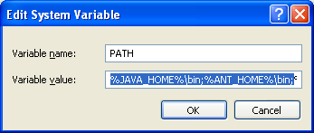
5 | In the Variable value text box, prepend the following text in front of the text that already exists in the Variable Value field.  %JAVA_HOME%\bin;%ANT_HOME%\bin;  Click OK.

Verifying the Environment Variables in Windows
To verify the environment variables have been set correctly, follow these steps:

Step | Action
1 | From the command line, enter:  echo %JAVA_HOME%  echo %ANT_HOME%  Both of these commands should return the location where you installed these tools.
2 | To verify your Java SDK installation, enter java –version from a command prompt. You should see java version "1.6.0_18".
3 | To verify your Ant installation, enter ant –version from a command prompt.  You should see: Apache Ant version 1.7.0 compiled on December 13 2006.

MySQL Installation and Configuration
A MySQL 5.0.45 server must be downloaded, installed and running in order for the NBIA installation to work successfully.

To download and install MySQL, follow the steps outlined on the MySQL website: http://downloads.mysql.com/archives.php?p=mysql-5.0&v=5.0.45

TIP | You should consult the following three links to successfully set up secure and well-performing MySQL servers, in preparation for installing NBIA:  - MySQL Security Guide - http://dev.mysql.com/doc/refman/5.0/en/security-guidelines.html  - Performance –  - General performance tuning - http://dev.mysql.com/books/hpmysql-excerpts/ch06.html  - InnoDB engine performance tuning - http://dev.mysql.com/doc/refman/5.0/en/innodb-tuning.html

MORE TIPS | - Record the MySQL root username/password chosen during the MySQL installation process, as you will need to use this as your database.system.user/ database.system.password later in the NBIA installation process.  - Note the MySQL port chosen during the MySQL installation process, as you will need to use this as your database.port later in the installation process.  - As part of the installation process, the default character set is set to latin1 for the NBIA MySQL database.

Once installed, you must configure My-SQL for NBIA (only for Linux).

Linux
Configure MySQL in Linux using the following steps:

Step | Action
1 | Lowercase Table Names in MySQL  Edit the /etc/init.d/mysqld (or mysql) file as follows:  - Locate the start() section and modify the mysqld_safe command (do not include the ellipses):  /usr/bin/mysqld_safe --lower_case_table_names=1 ...  - Restart the MySQL service for the changes to take effect:  Restart /etc/init.d/mysqld

Oracle Installation and Configuration
Setting up Oracle is beyond the scope of this document. For more information, refer to http://www.oracle.com/technetwork/database/enterprise-edition/documentation/index.html.

Downloading and Installing UPT
If you do not already have a User Provisioning Tool (UPT) installed, and you wish to manage user accounts for your NBIA application, you must install UPT.

Overview of UPT | UPT is used to provision users in the NBIA application. Each CBIIT application installs with its own Common Security Module (CSM) schema that has sample/default users and a role/permissions structure. To add additional users, you must provision the NBIA application as “NCIA” in the UPT. Then you can assign users to NBIA.  WARNING: because of shortcomings in NBIA’s current design, one instance of UPT can serve only instance of NBIA. In other words, for each instance of NBIA that is installed, there will need to be another instance of UPT installed.

You can download UPT 4.2 through the following link:

https://gforge.nci.nih.gov/frs/download.php/7298/CSM_UPT_42_Release.zip

For instructions on how to install UPT 4.2, refer to the chapter, UPT Installation and Deployment, in the following document.

https://gforge.nci.nih.gov/docman/view.php/12/18945/caCORE_CSM_v42_ProgrammersGuide.pdf .

NOTE | UPT 4.2 is backwards compatible to previous versions of CSM. When you provision the application in UPT 4.2, you are asked to specify the CSM version NBIA is using. You should enter v. 4.0.

Installing NBIA 5.0.2 Application and Services
To newly install the NBIA 5.0.2 application and services, follow the steps in this section:
- Downloading NBIA 5.0.2 files from GForge on page 9
- Installing a New NBIA on page 10
  - GUI Installer Method on page 10
  - Command-Line Method on page 25
- Configuring JBoss on page 28
  - Configuring JBoss Servers and MySQL Server to Run as Services on page 39
- Post-Installation Tasks on page 41
  - Starting Up NBIA on page 41

BEFORE YOU BEGIN | - Important: There must already be a pre-existing MySQL DB and connection username/password for NBIA to install into; NBIA does not create its own DB.  - If you have installed a previous version of NBIA 4.5, you must follow the upgrade procedures described in Upgrading NBIA 4.5 to 5.0.2 on page 33 to migrate to NBIA 5.0.2.

Downloading NBIA 5.0.2 files
To download the NBIA 5.0.2 files, follow this step:

Step | Action
1 | The installation files for NBIA 5.0.2 are each over 300MB. All of the files can be downloaded from the NBIA distribution folder here: https://gforge.nci.nih.gov/frs/?group_id=312.  - For a new command-line installer, download the NBIA_install_5.0.2.zip file  - For a command-line upgrader, download the NBIA_upgrade_5.0.2.zip file  - For a GUI installer that you can use to do a fresh NBIA 5.0.2 installation, download the NBIA_gui_distribution_5.0.2.jar  Remember the download location, as you will be using this file to run the installation in the steps that follow.

Server Components in NBIA 5.0.2 | These server components are installed and configured as part of the NBIA 5.0.2 installation. You do not need to do anything further to download or install these components.  - JBoss 4.0.5 (hosts the NBIA application and NBIA grid service)  - CTP

Installing a New NBIA 5.0.2

You can perform a new installation of NBIA v.5.0.2 using either of these two methods:
- A GUI Installation wizard. Instructions for this method begin on this page.
- A command-line installation. For instructions, see page 25.

GUI Installer Method of Installation

For detailed information on all of the GUI installer fields, refer to the documentation at this location: **FIXME**

BEFORE YOU BEGIN | If installing in Windows, double-clicking on the GUI installer jar is not recommended. Instead execute the GUI installer from the command shell. This will avoid the wrong JVM being employed to run the installer.

For performing an installation using the GUI Installer, follow these steps:

Step | Action
1 | Open a command prompt in the directory where you downloaded the NBIA_gui_distribution_5_0_2.jar. Enter this command to invoke the GUI installer: java –jar NBIA_gui_distribution_5_0_2.jar.
2 | The Installation Wizard opens to facilitate the installation process. Click Next to proceed through the pages of the wizard, beginning with progressing past the Welcome page. Selected screen shots are included to aid you in the installation process. Screen shot step numbers do not necessarily correspond with step numbers in these instructions.
3 | Review the release notes.
4 | You must accept the license agreement.
5 | Select the installation type. For a new installation, select Install.
6 | Navigate to the directory where you would like to install NBIA 5.0.2 using the Browse button.  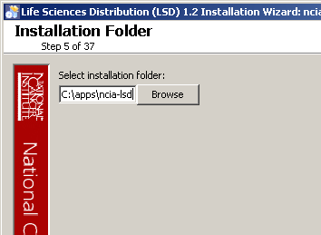  If the folder does not yet exist, click OK in the dialog box to indicate that you want the folder to be created.
7 | Select the components of NBIA to be installed. To install the entire system, select Everything.  Alternately, you can install selective components to allow them to be installed on different machines (in order to spread the load).
8 | Configure the NBIA JBoss server on the next two pages of the installation wizard. Fields on the page are populated with sensible default values.  You need to enter and confirm your JBoss Web Console Password.  The port values which are specified are the defaults and can be used unless you want to reconfigure the values because the ports are already in use.  Refer to the publicly available JBoss user’s guide at www.jboss.org for information about the fields on these pages.  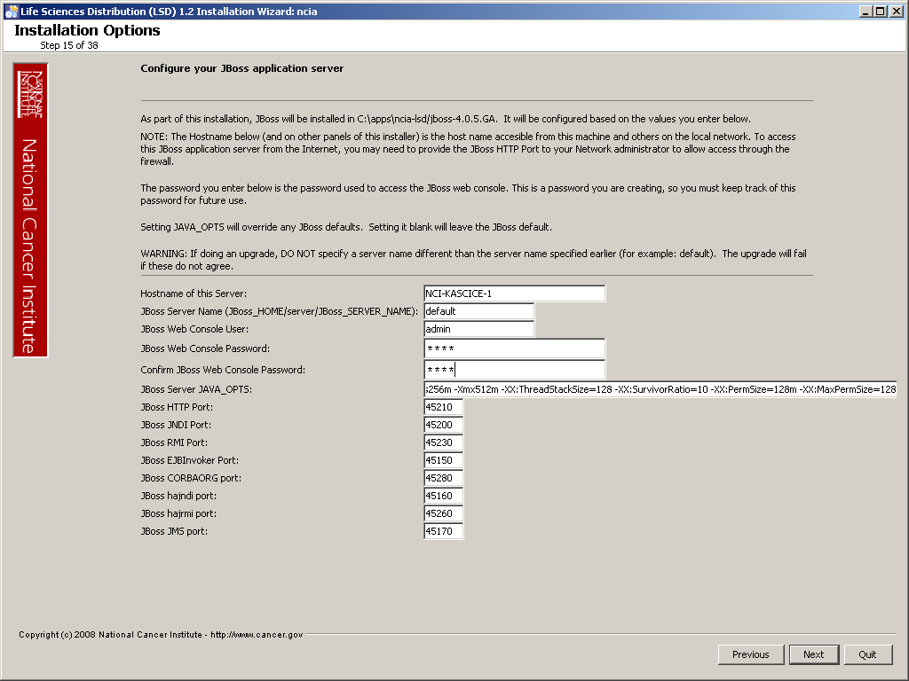
9 | Specify the authentication type that NBIA should use, LDAP or database. Database is the most likely choice if you aren’t sure what to select here.
10 | If LDAP was selected in the previous step, enter the appropriate configuration information for LDAP.
11 | Next are two pages that allow you to specify how to connect to the underlying database. The first page allows you to select whether Oracle or MySQL is to be used as the backing database.  In the second, specify the database connection information, including the name of the pre-existing database where the NBIA schema will be installed, and the pre-existing user which will be used by NBIA to connect to its database.  Regardless of the authentication type, the database connection parameters must be filled out. If you are installing everything or just the database, beware that all data in the specified database will be WIPED out.  For other components (JBoss Grid, CTP), this information is just used to fill out the configuration (and won’t be used to wipe anything).  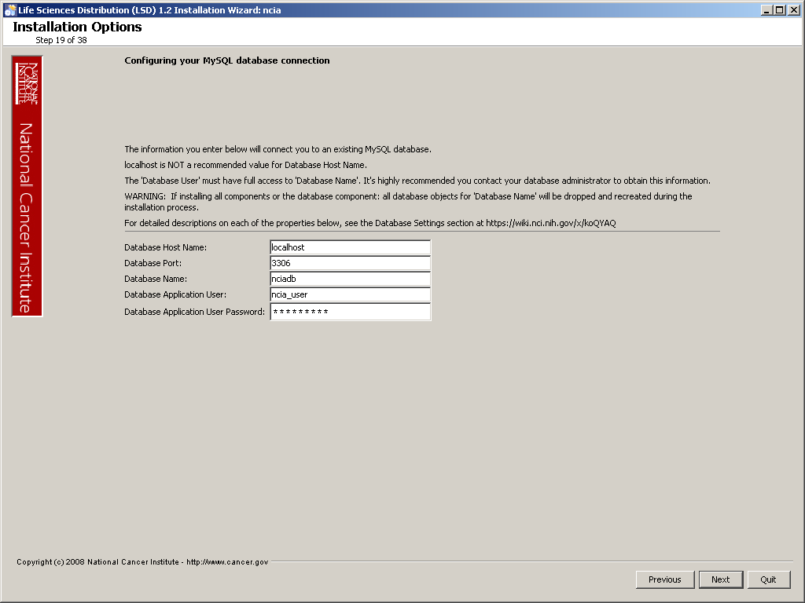  Error messages inform you if the following occurs:  - If the specified database host cannot be reached, or the field is blank.  - If the specified database does not already exist, or the NBIA DB user’s credentials are wrong.
12 | Specify the SMTP mail server connection information so that NBIA can send emails from users with new account requests.
13 | 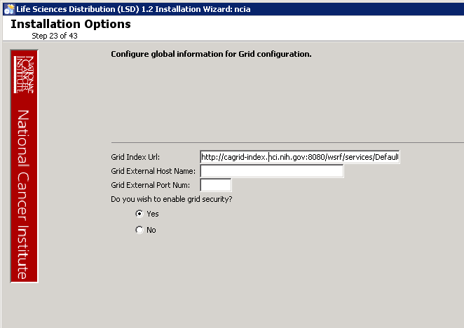  Specify the grid service index URL This will vary depending on your target grid (cagrid-index for production, cagrid-index-stage for staging).  If the service will be behind a proxy or firewall of some kind, specify an externally-visible hostname or IP address which the index service can use to communicate with your NBIA grid service. An example indexing URL is “imaging.nci.nih.gov”, and port number is “80”.  If this grid service should be configured to accept credentials to access potentially private data over https, select Yes for “Do you wish to enable grid security”.
14 | 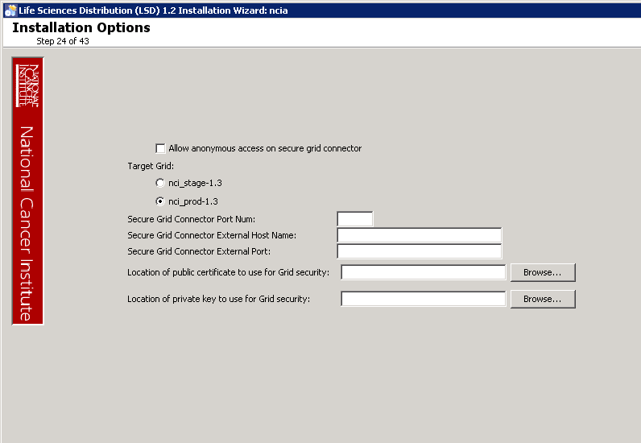  If grid security is enabled, this page allows customizing the configuration.  First, if the service should allow clients without credentials to retrieve public data, select “Allow anonymous access on secure grid connector”.  Second, choose the target grid for the service. This will affect SyncGTS/GridCA and Dorian configuration. If this is a “production” level grid service, then nci_prod-xx is the likely the correct choice. If this is a test instance, the stage grid is likely a better choice.  Third, configure the port for the secure service and an external name/port if applicable because of a proxy/firewall, etc.  Finally, specify the public certificate and private key for the service. This should likely be a host certificate retrieved through GAARDS. See http://cagrid.org/display/knowledgebase/Request+a+Host+Certificate for more information on requesting a host certificate.
15 | Specify the point-of-contact information needed for grid service registration. This information will span several pages of the install wizard.  An error message informs you of any required fields you miss.
16 | Configure the JBoss grid server on the next two pages of the installation wizard. Fields on the page are populated with sensible default values.  The port values which are specified are the defaults and can be used unless you want to reconfigure the values because the ports are already in use.  Refer to the publicly available JBoss user’s guide at www.jboss.org for information about the fields on these pages. 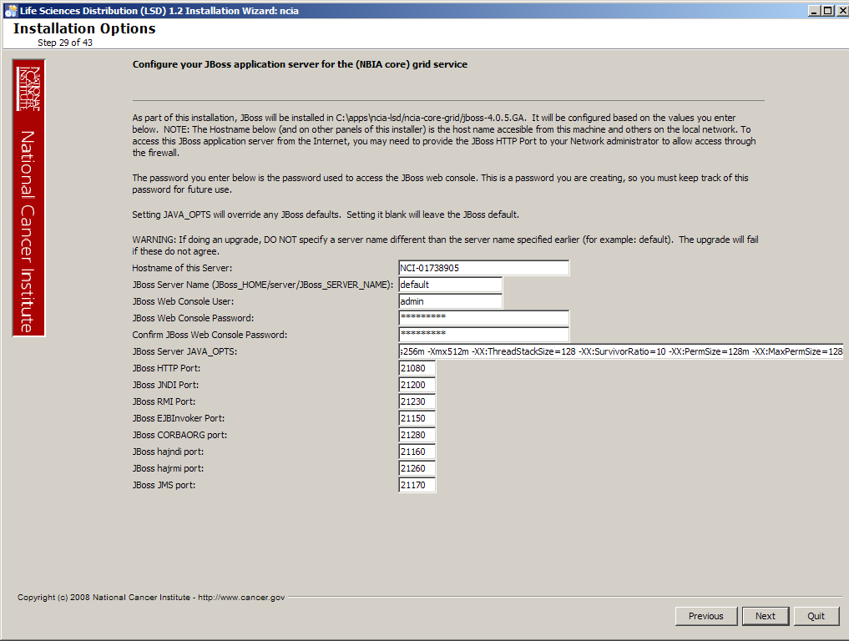
17 | In addition to the JBoss ports for the grid server, this page allows specifying a temporary directory for zipping DICOM files. The directory that is specified should be on a partition that has plenty of space.  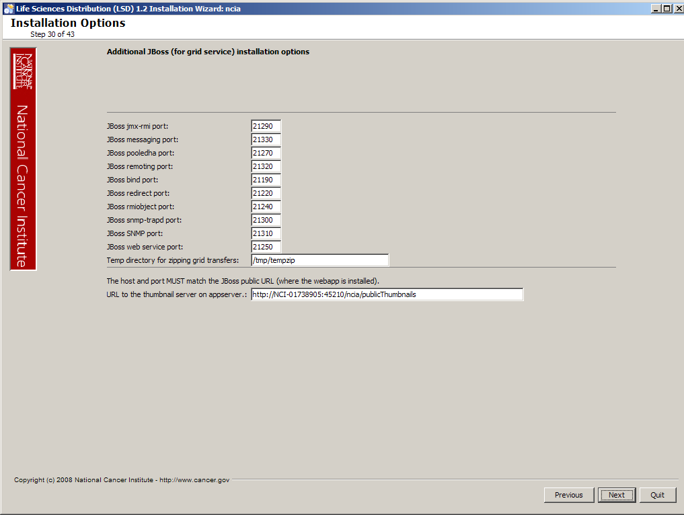
11  18 | Specify the runtime variables for NBIA. For detailed descriptions on each of the properties, see the Application Settings at https://wiki.nci.nih.gov/x/0I5XAg.  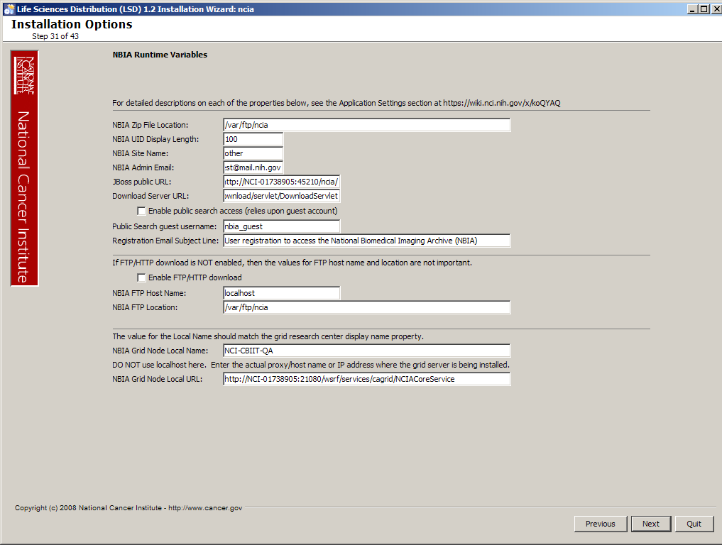
19  12 | Specify the configuration for the CTP (Clinical Trial Processor) Server.  - King user is a superadmin that has the privilege to shutdown the CTP server and others.  - Admin user has all the privileges of king without the privilege to shutdown the server.  WARNING: Please be sure to select a “Directory for Storage Service” that is outside of the NBIA installation directory. This will ease future upgrades.  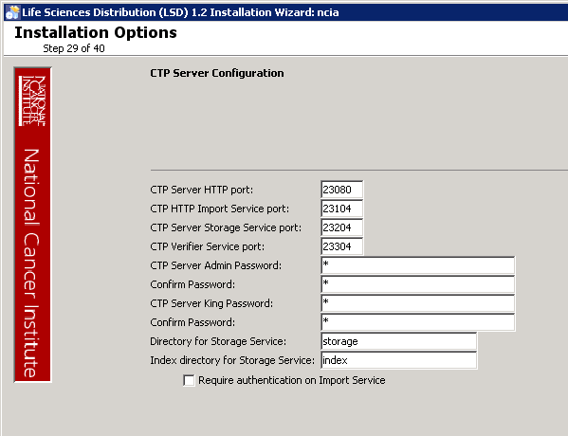
20  13 | Specify the configuration for the CTP (Clinical Trial Processor) Client.  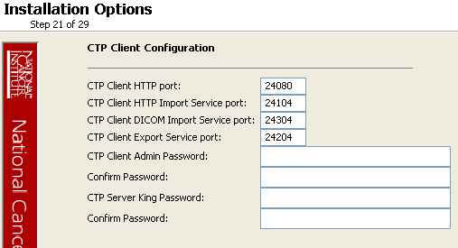
21 | The installer will allow for the selection of some “branding” customizations to the look of the NBIA user interface.  If no branding customization is desired, do no select any of these checkboxes and press Next to continue with the installation.  For each branding customization that is desired, select the relevant checkbox.  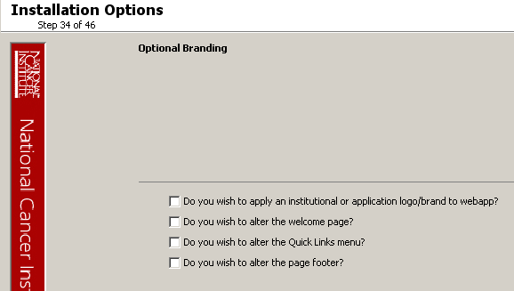
22 | If on the Optional Branding page, the checkbox for applying an institutional or application logo was selected, this page will allow for selecting the image files to use.  At least two image files must be selected from the local file system: one for the institution logo, and one for the background to be displayed behind the institution logo.  Additionally, the NBIA application logo can removed or replaced. If the logo is to be shown, but replaced, select an image from the local file system.  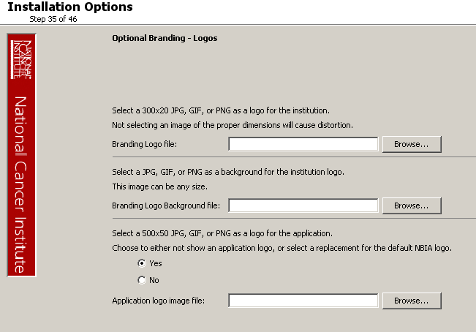
23 | If on the Optional Branding page, the checkbox for customizing the welcome page was selected, this page will allow for selecting the XHTML markup files to use.  All three files must be selected. For more information on authoring proper XHTML for this feature, please see: https://wiki.nci.nih.gov/x/SoZXAg.  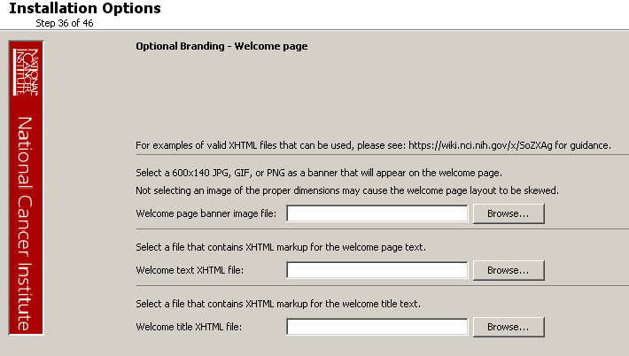
24 | If on the Optional Branding page, the checkbox for customizing the Quick Links was selected, this page will allow for selecting the XHTML markup file to use.  A file must be selected to continue. For more information on authoring proper XHTML for this feature, please see: https://wiki.nci.nih.gov/x/SoZXAg.  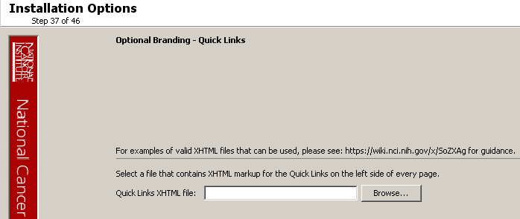
25 | If on the Optional Branding page, the checkbox for customizing the footer was selected, this page will allow for selecting the XHTML markup file to use.  A file must be selected to continue. For more information on authoring proper XHTML for this feature, please see: https://wiki.nci.nih.gov/x/SoZXAg.  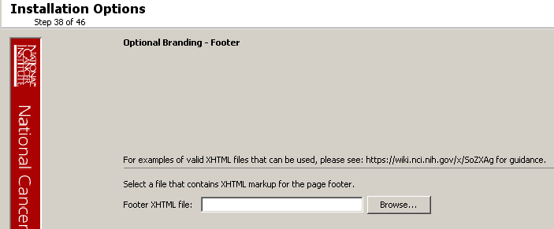
26 | The NBIA Download Manager requires that the jar files that constitute it be digitally signed. There is an option to let the installer generate a “self-signed” certificate. Alternately, if there is an existing (organization) certificate, that can be used.  To auto-generate the certificate, select Yes.
27 | If you opt to auto-generate the certificate, you can specify on this page where the keystore will be created. It also allows you to specify the alias of the key to be created.  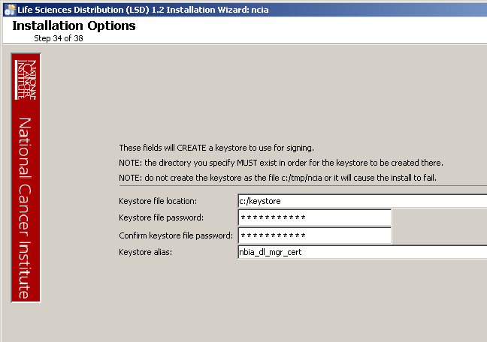
28 | If you opt to use an existing certificate, you can specify on this page where the keystore is (already) located.  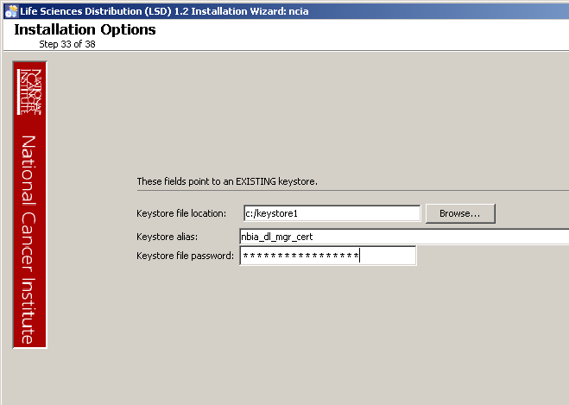
29 | Review the selected install type and the installation destination.  After you click Next from reviewing the installation destination, the installer runs. The installation wizard displays the installation progress and completion.
30 | When you are informed that the process is finished, click Done in the lower right corner of the wizard to close the installer.
31 | To verify NBIA installation:  - Open your web browser to http://<jboss.server.hostname>:<jboss.server.port>/ncia (example; http://hostname.com:45210/ncia  Refer to the <user home>/.installer-NCIA/NCIA_installer/install.properties file for the correct values.  - Enter nciadevtest as the user and changeme as the password.

32 | To verify that the NBIA Grid Service is up and running:  - Check that NBIA Grid Service appears on the local “services” page.  - Point a browser to the “services” page. The URL for this page is http://host:port/wsrf/services.  - Examine the page and ensure that “cagrid/NCIACoreService” appears on the page.  - Select the “wsdl” link next to “cagrid/NCIACoreService”.  - Examine the WSDL and check that the host and port in the //wsdl:import@location attribute are correct.  - Examine the WSDL and check that the host and port in //soap:address@location attribute are correct.  - Check that the NBIA Grid Service appears on the caGrid Portal.
33 | After successfully installing NBIA, make a backup of the <user home>/.installer-NCIA/NCIA_installer/install.properties file in a different directory for future reference.

Installing NBIA One Component at a Time

Important | When installing NBIA one component at a time, be aware of the following:  - The configuration parameters must agree across the components.  A few examples:  - All of the components should share the same database connection parameters.  - The grid component must communicate with the JBoss web application so the JBoss host and port must agree between these two components.  - The JBoss and database components both require configuration information about the guest account. These must agree.  - Strictly speaking, there is not a rigid order in which the components must be installed. However, the database is likely the first thing to install since the installer will try to start all the other components and if the database is not there, the servers will show errors upon starting. These servers must be restarted after the database is installed.  - The installer pages for the individual components are, for the most part, the same pages that are used when installing “Everything” so the documentation for the “Everything” path should largely apply.

Command-Line Method of Installation

About Properties

An important component of NBIA 5.0.2 command-line installation is configuring properties.

Overview of NBIA 5.0.2 Command-Line Installer Properties Files | When you do a command-line installation of NBIA 5.0.2 for the first time, you will work with the install.properties file included in the NBIA_install_5_0_2.zip.  If you are using the command-line to upgrade from the previous version of NBIA 4.5, you will work with the upgrade.properties file included in the NBIA_upgrade_5_0_2.zip. For more information about upgrading NBIA, see Upgrade Using Command-Line Installer on page 30.
Overview of Properties Files | When you installed the previous version of NBIA 4.5, you configured the install.properties. The NBIA_upgrade_5_0_2.zip that you must download to perform the upgrade to 5.0.2 includes another properties file, upgrade.properties. To complete the upgrade to NBIA 5.0.2, you should use the values in the install.properties to configure values in the upgrade installer wizard GUI, or the upgrade.properties file if you are doing a command-line method of upgrade.
See the steps below for more information.

In several instances in this section, property values must be modified. Note the following points about changing or entering variables.

Paths in .properties Files
NOTE | The paths in the .properties files should use forward slashes. For example, you would use application.base.path.window=C:/apps/NBIA, not application.base.path.window=C:\apps\NBIA. If you use backslashes, you will experience undesirable results.

Spaces in Property Values
NOTE | You should not put any spaces in the property values of *.properties files (e.g. install.properties). In Windows, note that the C:\Documents and Settings\<username> path contains spaces and the installation will likely fail. If you are using Windows, use a path such as C:/apps/NBIA.

More About Property Values
NOTES | - In the install.properties and the upgrade.properties files, any property value marked with uppercase REPLACE_* must be manually updated with the appropriate value.  - In each *.properties file, any property value marked with lowercase replace_* may be optionally updated with the appropriate value.  - In many of the steps below, there is reference to a database.system.user for your MySQL server. To determine which users are have full privileges to create and manage other databases, type show grants from a MySQL prompt to determine the correct level of privileges.

NBIA Port Usage
NOTE | Verify that default port values defined in install.properties and upgrade.properties files are not in use on your system by running netstat –a from the command line. If the ports are in use prior to installation, you will likely experience problems with your installation.

JBoss Errors During Installation
NOTE | You may receive an error such as Exception in thread "main" java.lang.NoClassDefFoundError: org/jboss/Shutdown. This should not be a problem, as the installer attempts to remove previously installed servers to prevent problems during the installation. If this is your first time installing NBIA, you may receive and disregard this error message.

Command-line Installation Steps
To install a new instance of NBIA 5.0.2 using the command-line, follow these steps:

Step | Action
1 | From the directory where you downloaded the NBIA_install_5_0_2.zip from Downloading NBIA 5.0.2 files on page 9, unzip the files  into a fresh directory. This location will be referred to as the <installer_directory> henceforth.  Example: <installer directory> = C:\NBIA_5_0_2_installer
2 | Note: Setting the property values is an important step in the install process. Before you complete steps 2 & 3, review About Properties on page 26. Follow steps 2 and 3 carefully.  Open the <installer_directory>/install.properties file, modify the values for your environment and save the file.  For detailed information on all of the properties, refer to the documentation at this location: https://wiki.nci.nih.gov/x/0I5XAg.  At a minimum, you will likely need to modify the values:  database.type  database.system.user  database.system.password  database.server  database.port  database.name  database.user  database.password  authentication.type  mail.smtp.server  jboss.server.hostname  jboss.web.user  jboss.web.password  ncia-core-grid.jboss.web.user  ncia-core-grid.jboss.web.password  ncia-core-grid.jboss.server.hostname  ncia-core-grid.tempZipLocation=  ncia-core-grid.jboss.thumbnailUrl  ctp.server.admin.password  ctp.client.admin.password  gov.nih.nci.NBIA.jboss.public.url  gov.nih.nci.NBIA.admin.email  gov.nih.nci.NBIA.jboss.mq.url  gov.nih.nci.NBIA.grid.local.node.name  gov.nih.nci.NBIA.imaging.server.url  It’s not mandatory, but it is appropriate to set the POC information for the grid service. This includes setting the properties named with these patterns:  research.center.*  point.of.contact.*
3 | Record these property values.  Note: You should not need to modify the other default values as we have chosen unique ports to reduce the risk of other applications using the same values. However, be sure to verify that the ports in this file are not being used by other applications.
4 | From the command line, navigate to <installer_directory> (Example:cd C:/NBIA_5_0_2_installer), and type ant. This initiates the installation process. The anticipated duration is anywhere from 5-20 minutes, depending on your system’s speed, power and memory.  The installer installs the NBIA schema in the specified pre-existing database in your database server. It installs, configures, and starts the JBoss servers for the web application and grid service and it does the same for the CTP server.
5 | To verify NBIA installation, open your web browser to http://<jboss.server.hostname>:<jboss.server.port>/ncia  For example: http://hostname.com:45210/ncia  Refer to the <installer_directory>/install.properties file for the correct values.  Login as nciadevtest as the user and changeme as the password.
6 | After successfully installing NBIA, make a backup of the <installer_directory>/install.properties file in a different directory for future reference.

Upgrading NBIA 4.5 to 5.0.2
This section describes how to upgrade your product from NBIA 4.5 to NBIA 5.0.2.
The instructions in this section apply only if you have already installed NBIA version 4.5.x.

You can perform an upgrade installation of NBIA v.5.0.2 using either of these two methods:
- A GUI Installation wizard. Instructions for this method begin on this page.
- A command-line installation. For instructions, see page 36.

Before You Begin | - Important: Backup the 4.5 database. You need to create a reliable copy of your entire NBIA database—the DDL and DML.  - Important: Backup the jboss.home directory. To do this, make a copy of the NBIA.home folder along with any artifacts from the initial installation, such as the property files, already mentioned.  - Important: You cannot upgrade from NBIA with MySQL to a new NBIA that uses Oracle. You must install a fresh NBIA with Oracle and migrate the data manually. This whole section assumes you are upgrading from MySQL (to NBIA 5.0.2 with MySQL) since that is the only database that was supported by NBIA 4.5. Please contact NCICB application support if you require help with migration.

If you are performing a new installation, go directly to the installation of version 5.0.2, Installing NBIA 5.0.2 Application and Services, on page 8.

NBIA 4.5 Users Upgrading to NBIA 5.0.2 | - The directions in this section presume that you have a valid and functioning NBIA 4.5. That assumes that Java SDK, Apache Ant and MySQL have all been successfully uploaded and installed, as described on page 3 in this document.  - The upgrade to a given version of NBIA may add new constraints to the data model. This is typically done in order to stop erroneous submissions from happening. If such submissions have already occurred, there may already be duplicate or corrupt data in the database. The upgrade will fail in such a case, and the corrupt data needs to be cleaned out before the upgrade can be successful.

Upgrading NBIA Using the GUI Installer

For detailed information on all of the GUI installer fields, refer to the documentation at this location: https://wiki.nci.nih.gov/x/koQYAQ.

To perform an upgrade to NBIA 5.0.2 using the GUI Installation Wizard, follow these steps:

Step | Action
1 | Open a command prompt in the directory where you downloaded the NBIA_gui_distribution_5_0_2.jar and invoke the GUI installer like this: java –jar NBIA_gui_distribution_5_0_2.jar.
2 | The Installation Wizard opens to facilitate the installation process. Click Next to proceed through the pages of the wizard, beginning with progressing past the Welcome page. Screen shots are included where helpful.
3 | Review the release notes.
4 | You must accept the license agreement to continue.
5 | Select the Upgrade installation type.
6 | Select the components of NBIA to upgrade. To upgrade the entire system, select Everything.  Alternately, selective components can be upgraded per machine.
7 | Select the location for the previous installation. If the path pointing to the NBIA installation to be upgraded is incorrect, an error message appears.  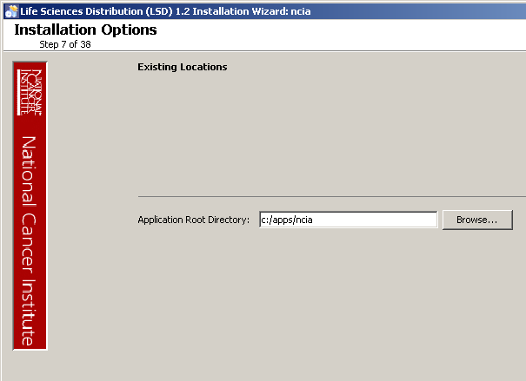
8 | For each JBoss container, the upgrader requests the server name to upgrade.  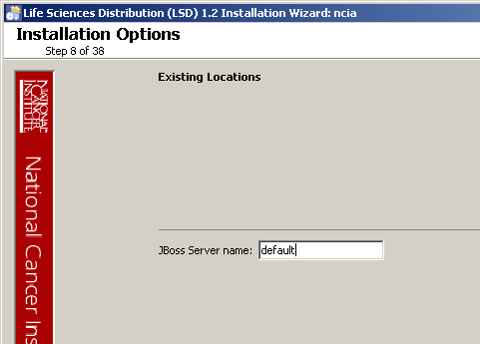
7  9 | The installer software now inspects the application base path to determine the existing configuration (the best that it can), and the install wizard registers this action.
10 | From here on, the upgrade process looks almost exactly like the install process, described starting on page 10 in this document. The installer software has populated the defaults for all fields from the existing installation the best that it can.  For fields that are new in this release, there are sensible defaults.

Overview of Properties Files | When you installed the previous version of NBIA, you configured the install.properties. The NBIA_upgrade_5_0_2.zip that you must download to perform the upgrade to 5.0.2 includes another properties file, upgrade.properties. To complete the upgrade to NBIA 5.0.2, you may need to use values in the install.properties to configure values in the upgrade installer wizard GUI, or the upgrade.properties file if you are doing a command-line method of upgrade. In some instances, there are “readers” that will figure out the existing values automatically.  See the steps below for more information.

Upgrading NBIA Using Command-Line Installer

To perform an upgrade to NBIA 5.0.2 using the command-line, follow these steps.

Step | Action
1 | From the directory where you downloaded the upgrade zip file from Downloading NBIA 5.0.2 files on page 9, unzip the files into a fresh directory. This location will be referred to as the <installer_directory> henceforth.  Example: <upgrade_installer directory> = C:\NBIA_5_0_2_upgrade_installer
2 | Edit the default properties in the <upgrade_installer_directory>/ upgrade.properties file. To do so, open both properties files, the one you configured originally when you installed the previous version of NBIA 4.5.x. (<install.properties file>)and the <upgrade_installer_directory>/ upgrade.properties file.  Note: Where there are duplicate attributes, the values must be the same in both files.  Copy each entry you modified in the 5.0.2 installation file and paste it in the corresponding location in the upgrade.properties file, replacing the default text, as appropriate. All the properties that appear in upgrade.properties appear in install.properties (but not vice versa). Consult the Command-Line Method of Installation of this guide on page 26 for more background on the meaning of the properties.
3 | Record these property values.  Note: You should not need to modify the other default values as we have chosen unique ports to reduce the risk of other applications using the same values. However, be sure to check the *.properties to verify that the ports in this file are not being used by other applications.
6  4 | From the command line, navigate to <upgrade_installer_directory>/ (Example:cd C:\NBIA_upgrade_installer), and type ant. This initiates the upgrade process. The anticipated duration is anywhere 7-15 minutes depending on your system’s speed, power and memory.  The installer upgrades your existing NBIA database on your MySQL server, starts your existing JBoss servers and starts up the grid service for the NBIA application.  Notes regarding upgrade:  When the installer detects that a database exists, it warns you to back it up, which you were instructed to do earlier in this process. Press Y to proceed.
6  5 | To verify NBIA installation, open your web browser to http://<jboss.server.hostname>:<jboss.server.port>/ncia (example: http http://hostname.com:45210/ncia) and enter nciadevtest as the user and changeme as the password. Refer to the original install.properties for the correct jboss.server.hostname and jboss.server.port values.

Configuring JBoss

NOTE | For optimal performance, you must modify your JBoss 4.0.5 configuration to increase the amount of available memory for the NBIA application. Directions for doing this in Windows are in the following step 1.

To configure JBoss in Windows, follow these steps:

Step | Action
1 | Add the following entry to the JBoss run.bat file which is located will be located at <application_root_directory>/jboss-4.0.5.GA/bin/run.bat. Add the text right after the line ”rem Add -server to the JVM options, if supported”.  -server –Xms1024m –Xmx1024m -XX:ThreadStackSize=128 -XX:SurvivorRatio=10 -XX:PermSize=128m -XX:MaxPermSize=128m -Dsun.rmi.dgc.client.gcInterval=3600000 -Dsun.rmi.dgc.server.gcInterval=3600000 -Djava.awt.headless=true  Warning: Be careful when copying and pasting from this document, whether PDF or MS Word. No spaces must come before and after the columns. A safe way to ensure that the text has no unwanted space and unwanted characters is to copy the text into a blank text editor such as NotePad first. Correct the spacing, then copy and paste back into the run.bat file.
2 | Restart your JBoss 4.0.5 server for the changes to take effect. The method of doing this may depend on the start/stop/restart scripts you created after the installation. Most commonly, you can execute shutdown.bat and then run.bat under $JBOSS_HOME/bin. Refer to the publicly available JBoss user’s guide at www.jboss.org for more information.

Configuring JBoss Servers and MySQL Server to Run as Services

NOTE | MySQL, and the two JBoss servers that make up NBIA, and the JBoss server optionally installed for UPT, must run continually as services. The instructions in this section cover all of these scenarios. For a NBIA 5.0.2 deployment, there are at least four servers, and if UPT is installed, five servers:  - JBoss 4.0.5 (for NBIA application and grid service)  - MySQL 5.0.45  - CTP (Clinical Trial Processor)

Running JBoss as a Service

NOTE | The default NBIA installation runs JBoss as a command line process using the user currently logged on. Therefore, when you log out as this user, JBoss is no longer available for NBIA. For that reason, it is recommended that you configure your JBoss servers to run as a Linux or Windows service. The instructions are contained in this section.

To run JBoss as a service, follow these steps:

Step | Action
1 | Linux  See http://wiki.jboss.org/wiki/Wiki.jsp?page=StartJBossOnBootWithLinux.
2 | Windows  To run an existing JBoss command line installation as a service, follow the directions for creating a user-defined service at http://support.microsoft.com/kb/137890/EN-US/  Note: You must have access to the Windows Resource Kit.

Running MySQL as a Service

NOTE | It is assumed that your MySQL server was installed as a service. If it was not, follow these recommendations for installing this server as a service.

To run MySQL as a service, follow these steps:

Step | Action
1 | Linux  See http://www.redhat.com/docs/manuals/enterprise/RHEL-AS-2.1-Manual/cluster-manager/s1-service-mysql.html.
2 | Windows  When installing MySQL server on Windows, choose the option to run MySQL as a Windows service.

Post-Installation Tasks

Starting Up NBIA | Note that if JBoss and CTP are not installed as services, they must be manually started/re-started. The following files will start the respective servers.  On Windows:  - JBoss: ncia/jboss-4.0.5.ga/bin/run.bat  - Grid JBoss: ncia/ncia-core-grid/jboss-4.0.5.ga/bin/startup.bat  - CTP: ncia/CTP-server/CTP/ctp.bat  On Linux:  - JBoss: ncia/jboss-4.0.5.ga/bin/run.sh  - Tomcat: ncia/ncia-core-grid/jboss-4.0.5.ga/bin/startup.sh  - CTP: ncia/CTP-server/CTP/ctp.sh

Using UPT to Add NBIA Users
NOTE | To add users to NBIA, you must provision the NBIA application as “NCIA” in the UPT. See Downloading and Installing UPT on page 8.

To use the UPT, follow these steps:

Step | Action
1 | Install UPT.
2 | Launch a browser and access UPT via value of application.url (from UPT’s install.properties).
3 | Log in to UPT, using the following profile:  - Login ID=superadmin  - Password=changeme  - Application Name=csmupt
4 | Select the User tab at the top of the page, and click Create a New User.
5 | Enter Login Name, User First Name, User Last Name, User Password, User Password Confirm. Click Add.
6 | On the Application tab at the top of the screen, click Create a New Application.
7 | Enter the following parameters:  - Application Name=NCIA  - Application Description=<Application Description>  - Application Declarative Flag=Yes  - Application Active Flag=Yes  - Application Database URL=jdbc:mysql://${database.server}:${database.port}/${NBIA.database.name}  - Application Database User Name=${NBIA.database.user}  - Application Database User Password=  ${NBIA.database.password}  - Application Database Confirm Password=  ${NBIA.database.password}  - Application Database Dialect=org.hibernate.dialect.MySQLDialect  - Application Database Driver=com.mysql.jdbc.Driver  When you provision the application in UPT 4.2, you are asked to specify the CSM version NBIA is using. You should enter v. 4.0.  NOTE: ${NBIA.xxxx} should be interpreted as the value of property xxxx when NBIA was installed (as opposed to any UPT installation property value)
8 | Click on Add > Associated Admins. then click on Assign Admin.
9 | Highlight the user you want to be admin of the application, and click Assign Admin.
10 | Log out of UPT.
11 | Log in to UPT (from UPT’s install.properties). Use the following login profile:  - Login ID=<User created above>  - Password=<Password for User created above>  - Application Name=NCIA
12 | Add users to the NBIA application as you did above.
13 | Click Logout.

Contacting Application Support
NCICB Application Support | http://ncicb.nci.nih.gov/NCICB/support  Telephone: 301-451-4384  Toll free: 888-478-4423

